A Forrest 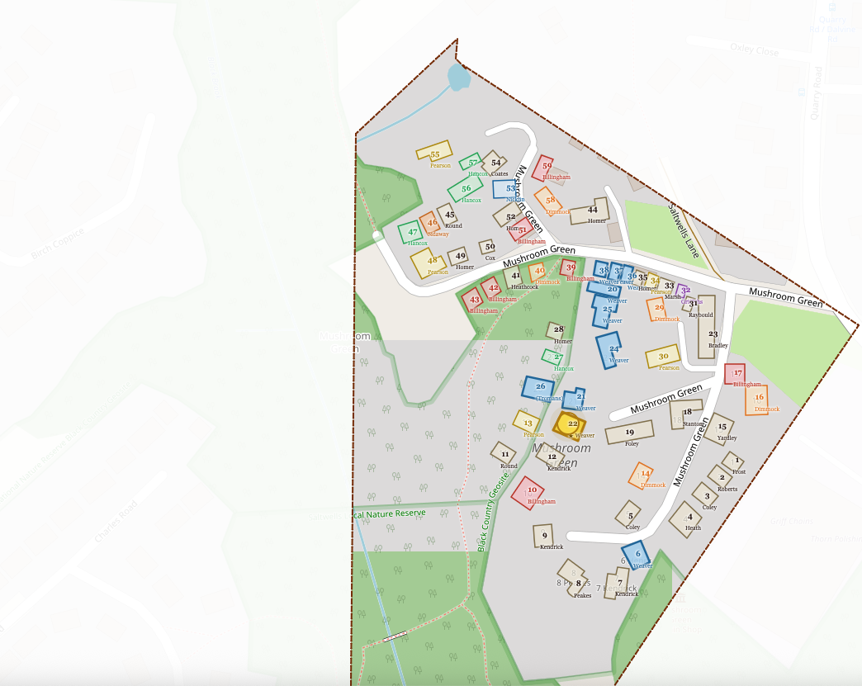
A | Forest | R206 | G219 | B179
B | Village | R249 | G242 | B224
C | Grass | R198 | G232 | B167
D | water/Brook | R121/65 | G177/139 | B213/193
E | Birch Coppice | R249 | G242 | B224
F | Background | R241 | G238 | B215
G | Contour | R227 | G236 | B230

